
Architecture Vision
Project [AP01] Hybrid Observability & Capacity
Client TDI
Table of Contents
1 Purpose of this Document 3
2 Principle Template 4
3 Summary of Principles 5
4 Business Principles 6
5 Data Principles 7
6 Application Principles 8
7 Technology Principles 9

Document Information
Project Name: | [AP01] Hybrid Observability & Capacity
Prepared By: | John / Mahesh / Phil | Document Version No: | 0.1
Title: | Architecture Vision | Document Version Date: | 18/10/24
Reviewed By: |  | Review Date:
Distribution List
From | Date | Email

To | Action* | Due Date | Email
* Action Types: Approve, Review, Inform, File, Action Required, Attend Meeting, Other (please specify)
Document Version History
Version  Number | Version  Date | Revised By | Description | Filename
0.1 | 18/10/24 | John / Mahesh | Initial Version | Architecture Vision

Purpose of this Document
The Architecture Vision is created early on in the project lifecycle and provides a high-level, aspirational view of the end architecture product. The purpose of the vision is to agree at the outset what the desired outcome should be for the architecture, so that architects can then focus on the critical areas to validate feasibility. Providing an Architecture Vision also supports stakeholder communication by providing an executive summary version of the full Architecture Definition.
It may be that the Architecture Vision is documented using a wiki or as an intranet rather than a text-based document. Even better would be to use a licensed TOGAF tool that captures this output.
This template shows “typical” contents of an Architecture Vision and can be adapted to align with any TOGAF adaptation being implemented.

Problem Description

Stakeholders and their Concerns
<<The purpose of this section is to describe the stakeholders for the vision together with any concerns they may have.
Mandatory/optional: This section is mandatory.
In terms of quality criteria, this section should make clear:
a. Any stakeholder concerns about the business
b. Any stakeholder concerns about the exercise being undertaken>>

List of Issues/Scenarios to be Addressed
<<The purpose of this section is to define the business context and problem description for which the vision of the target architecture has been produced.
Mandatory/optional: This section is mandatory.
In terms of quality criteria, this section should make clear:
a. Business vision statement for the target architecture
b. Pictorial representation of business context
c. Change drivers and opportunities behind this vision for the target architecture>>

Business Vision Statement
<<The purpose of this section is to define the business vision statement of the target architecture.
Mandatory/optional: This section is mandatory.
In terms of quality criteria, this section should make clear:
a. Business vision statement(s) for the target architecture>>

Business Vision Diagram
<<The purpose of this section is to provide one or more suitable pictorial representation(s) that explain the business context and business problem. They are required in order to obtain senior executive engagement with this activity.
Mandatory/optional: This section is optional but recommended.
In terms of quality criteria, this section should make clear:
a. Diagram(s) explaining the problem statement for the target architecture
b. Description of business vision diagram>>

Change Drivers & Opportunities
<<The purpose of section is to identify the change drivers and opportunities behind this vision for the target architecture.
Mandatory/optional: This section is mandatory.
In terms of quality criteria, this section should make clear:
a. Change drivers that will impact decisions made for the target architecture
b. Opportunities that can be leveraged for the target architecture>>

Detailed Objectives
<<The purpose of this section is to describe the detailed objectives that need to be fulfilled by the target architecture. The previous section looks at the business problem, whereas this section determines the objectives, for the architecture solution, that will resolve the business problem.
Mandatory/optional: This section is mandatory.
In terms of quality criteria, this section should make clear:
a. Business objectives to resolve the business problem
b. Technology objectives, such as decommissioning>>

Environment and Process Models

Business processes | Environment | Customers / Users interacts | Information Flows
TRC | All technologies and processes in all environments | ITAOs, Control Owners, Technology Owners | Tech owners provide a compliant technology version.  Control owners ensure ITAOs plan and upgrade to compliant version.
RHEL Upgrades | All environments.  GCP and On-Prem. | ITAOs, Control Owners,  Unix Engineering | Unix engineers provide a compliant new RHEL version.  Control owners ensure ITAOs plan and upgrade to compliant version.
Right-Sizing | All environments on-prem initially | ITAOs, Control Owners,  FinOps | FinOps provide insights into underutilised infrastructure.  ITAOs request decom or resizing of their infrastructure.
MRA (Unauthorised Software) | All software processes in all environments (only for CUSO app initially) | ITAOs, Control Owners, Technology Owners | Tech owners provide a compliant technology version.  Control owners ensure ITAOs upgrade, uninstall, migrate or register unauthorised software.
FIM  (File Integrity Management) | Production environments | ITAOs, CSMs, Deployment Tool Owners, Change Management | Deployment tool owners provide a way that ITAOs can declare which files will be deployed as part of a release. Control owners ensure that all files that change are linked to a change that declares those files will be changed at that time.  Irregular files are remediated.
ITAM | All technologies and processes in all environments | ITAM Control Owners | Control owners identify end or life software or hardware and ensure it is remediated.
Anomalies | All technologies and processes in all environments | ITAOs | ITAOs detect anomalies using monitoring and execute tasks either manually or using automation to bring application behaviour back to normal.

Actors and their Roles and Responsibilities

Human Actors and Roles
Human Actors | Roles for Target Architecture
Control Owners | Control owners will:  Create a detective policy per compliance control.  Create instructions per compliance control.  Create a change template per compliance control.  Work with the technology owner to ensure automation is in place to remediate the control.
Technology Owners | Technology owners will:  Create a compliant solution.  Create reusable automation to remediate non-compliant solutions on to compliant solutions.
ITAOs | ITAOs will receive notifications of non-compliancy, understand instructions and then execute the automation to remediate the control issues with automatically raised change tickets of specified change template.

Computer Actors and Roles
Computer Actors | Roles for Target Architecture
Detect and notify. | The detection process will apply the detective control policy created by the control owners and load the result sets into Control Workbench with remediation instructions provided by control owner. Control Workbench will notify the ITAO that contr0l remediation is required.
Change raise, execute, verify and close | The remediating change tasks (raise, execute, verify and close) will be automatically orchestrated.
Track and Report | Real time control remediation information will be available for tracking or reporting purposes in standard dashboards and reports.

Requirements
An integrated data driven Automation Ecosystem that uses detective policies linked to reusable automation to remediate compliancy issues.

- A mature discovery and detection data lake for configuration of software and hardware.
- A mature and holistic observability data lake for performance and health of software and hardware.
- Ability for control owners to specify a detective policy that specifies the field(s) and the values(s) to detect non-compliancy.
- Ability for control owners to enter compliance remediation instructions.
- Ability for control owners to create a standard change template per control.
- Ability for control owners to link a reusable automation asset (e.g. an Ansible role or playbook) to the detective compliance policy that it remediates.
- Automated loading of detected non-compliance data, remediation instructions, change template and automation asset reference into Control Workbench for notification to user.
- Ability for ITAOs to specify a detective policy that specifies the field(s) and the values(s) to detect as anomalies.
- Ability for ITAOs to enter anomaly remediation instructions.
- Ability for ITAO to create a standard change template per control.
- Ability for ITAOs to link a reusable automation asset (e.g. an Ansible role or playbook) to the detective anomaly policy that it remediates.
- Automated loading of detected anomaly data, remediation instructions, change template and automation asset reference into dbORBIT for notification to user.

Resulting Architecture Model

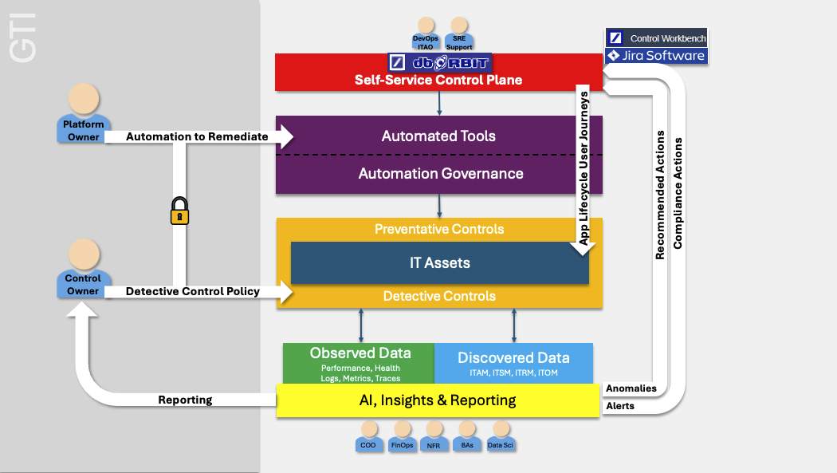

Constraints
Time Constraints:
Cost Constraints:
Scope Constraints:
Regulatory Constraints:
Design Constraints:
Organisational Constraints:
Technical Constraints:

IT Principles
<<The purpose of this section is to describe the principles that can be leveraged in order to define the target architecture.
Mandatory/optional: This section is mandatory if existing principles need to be taken into consideration.
In terms of quality criteria, this section should make clear:
a. Principles that can be leveraged in order to define the target architecture>>

Architecture Supporting the Process
<<The purpose of this section is to describe the target architecture.
Mandatory/optional: This section is mandatory.
In terms of quality criteria, this section should make clear:
a. High-level diagram(s) of the target architecture
b. Description of the diagram(s)>>

Requirements Mapped to Architecture
<<The purpose of this section is to describe the high-level business and technology requirements that map onto the target architecture.
Mandatory/optional: This section is mandatory.
In terms of quality criteria, this section should make clear:
a. Existing business requirements such as goals and objectives that map onto the target architecture
b. Existing technology requirements that map onto the target architecture>>

End Vision Statement
<<A statement executive summary of the end vision of the architectural effort.
Begin with the end in mind!>>

